JavaScript Events

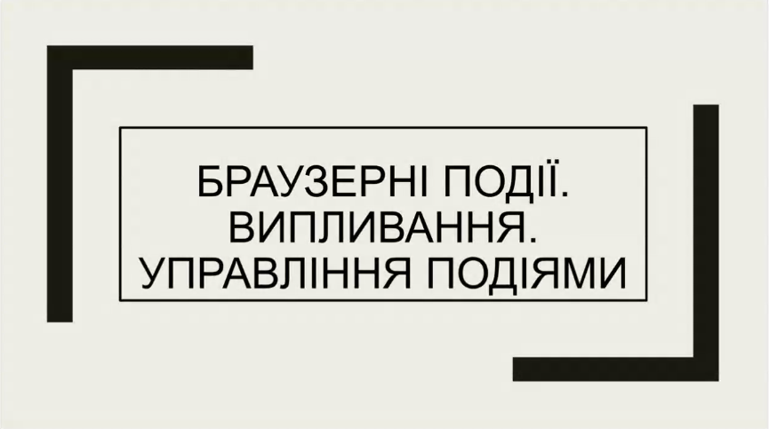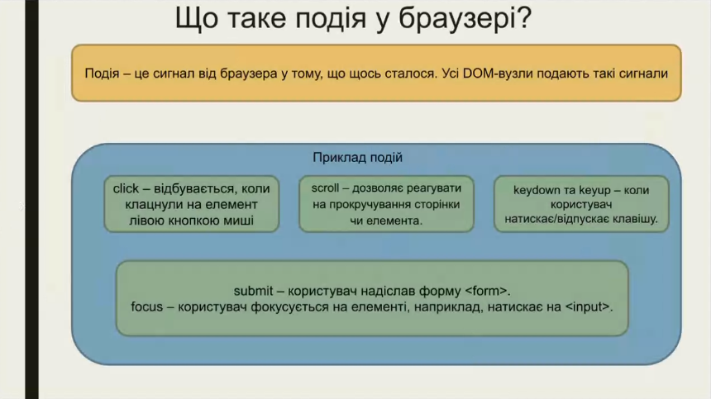

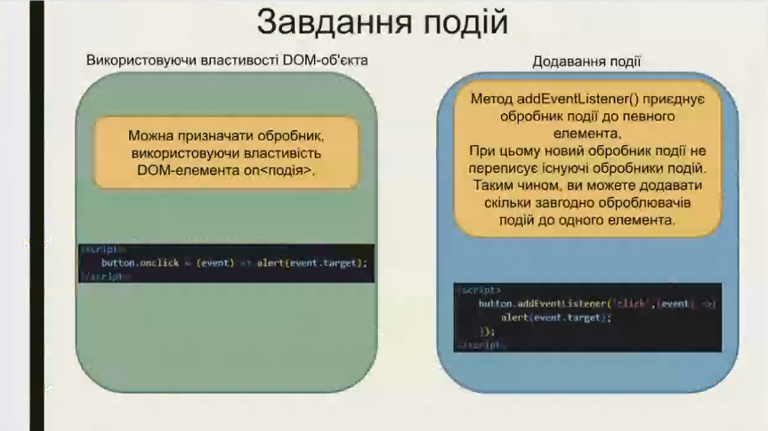

const button = document.querySelector("#myButton")

button.onclick = function (event) {

    console.log(event);

// Output: PointerEvent(...)

}

button.onclick = function (event) {

    // console.log(event);

    event.target.style.backgroundColor = "green";

};

Same as

button.onclick = function (event) {

    // console.log(event);

    button.style.backgroundColor = "green";

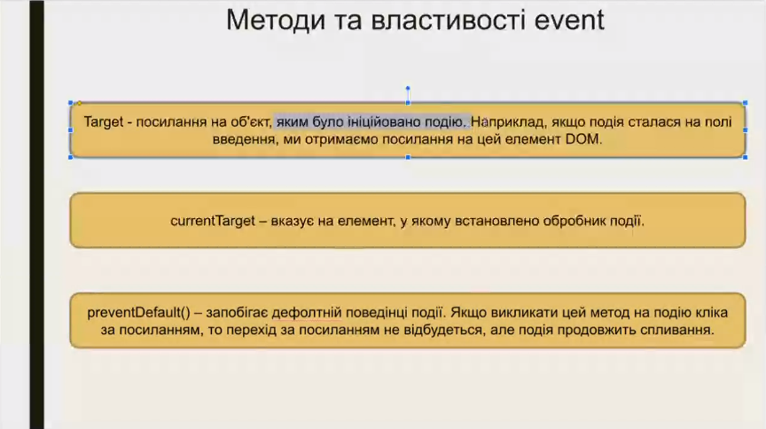}

const buttons = document.getElementsByClassName("button");

for (let button of buttons) {

    button.onclick = (event) => {

        event.target.style.backgroundColor = "red";

    }

}

button.addEventListener("click", (event) => {

    event.target.textContent = "Дякую що натиснув на мене"

    alert(event.target.textContent)

});

const div = document.querySelector("div")

div.addEventListener('click', (event) => {

    console.log("ви натиснули")

    event.target.style.backgroundColor = "green"

    event.currentTarget.style.backgroundColor = "pink"

})

Нажатие на правую кнопку мыши: открывается контекстное меню (Context Menu)

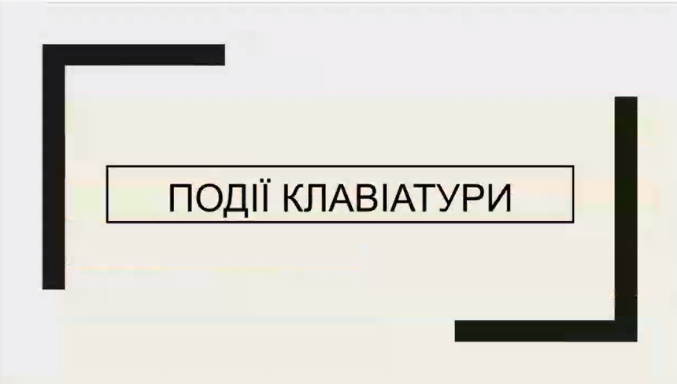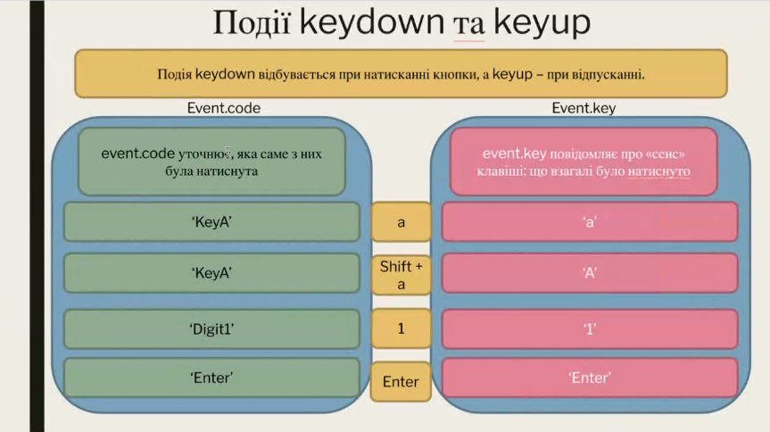

function keyHandler(event){

    console.log(event.code);

}

document.onkeydown = keyHandler

function keyHandler(event){

    if (event.code == "KeyB"){

        document.body.style.backgroundColor = "green";

    }

}

document.onkeydown = keyHandler

document.addEventListener("contextmenu", (event) => {

    event.preventDefault();

    document.body.style.backgroundColor = "red";

});